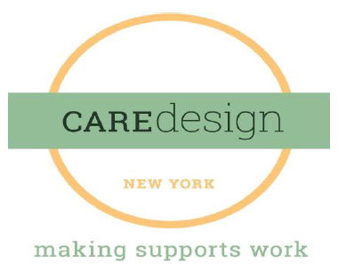

Dear Prospective CDNY Colleague:

We are most pleased to begin the process of engaging with you as we move toward our goal of bringing you into employment effective July 1, 2018. This is such a pivotal time in the field of intellectual and developmental disabilities. Jim, Anne, and I are looking forward to working with you to build our new organization together, providing the highest quality services and supports to individuals and their families. We understand that our organization is defined by the quality and responsiveness of the actual services delivered and as such we are committed to ensure that we have the best workforce. We are committed to providing the highest, fair and equitable compensation and benefits possible initially and into the future.

One of the beginning steps in that process is for us to provide you with an offer of compensation and benefits. By completing and submitting the document in the link below, you will help us in determining your compensation. The compensation rates offered will be based on a number of factors including your position at Care Design NY, years of experience as a service coordinator and within the field of developmental disabilities, education, bilingual competency including sign language, and certifications that are beneficial to the role. Compensation will also be adjusted based on your location in the state.

Our intention is to provide you with an offer of employment by March 16, 2018. In order to meet that deadline, we need you to please click on the link below to complete the attached form and submit it to us no later than **March 7, 2018.**

We know that this is a time of uncertainty for you because this is a time of change and not everything is known yet about how that change will affect you. Care Design NY is committed to making this transition in employment as smooth as possible. To that end, please know that we commit to the following:

* While you will not be able to carry over any paid leave time from your agency, your hire date with your current agency will be the date that Care Design New York will use to determine your Paid Time Off accrual level so that you will accrue time giving credit for your previous longevity. You will not have to “start over” on the accrual schedule with Care Design NY.
* Time-off is important. Based upon your years of service in your current organization, we will be providing immediate time-off (both Holiday and PTO) for your accrual bank upon employment with us.

We are very excited to be able to partner with you in the changes to come, as we transition the current provision of service coordination to care management on July 1. Thank you for all that you do every day to improve the lives of the individuals you support. It is a privilege to join with you in such a significant transformation in our field.

Please click this link:

[http://bit.ly/2opzt](http://bit.ly/2opzt2b)**[2b](http://bit.ly/2opzt2b)**

You can also access the Employment Transition Information Form directly from our website at <http://caredesignny.org/careers/>

If you have any questions at all, please don’t hesitate to contact me by email at [lreese@caredesignny.org](mailto:lreese@caredesignny.org) or by phone at 518-235-1888.

Sincerely,

Lisa Reese

Vice President of Human Resources